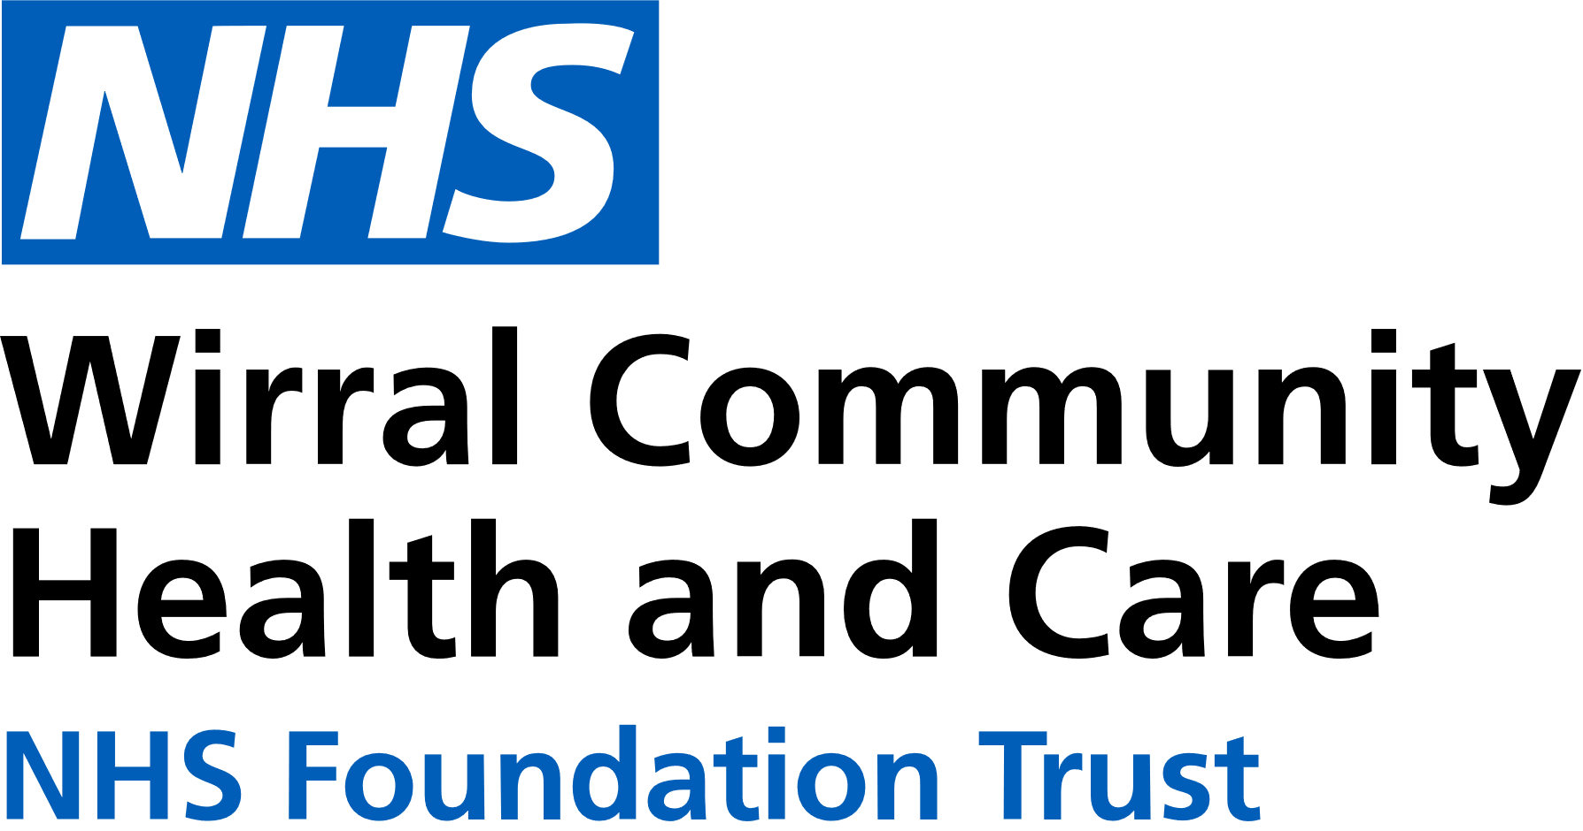

0151 604 7307 (option 1)

[wcnt.cardiacrehab@nhs.net](mailto:wcnt.cardiacrehab@nhs.net)

Use the below list to keep track of when you have attended each module.

|  |  |
| --- | --- |
| **Educational module** | **Date attended** |
| Atrial fibrillation (AF) and stroke |  |
| Basic Life support and Automated External Defibrillator (AED) use |  |
| Cardiac conditions |  |
| Cardiovascular disease (CVD) and the heart |  |
| Exercise for a healthy heart |  |
| Getting back on track |  |
| Healthy eating |  |
| Healthy mind, healthy heart |  |
| Heart failure (HF) explained |  |
| Managing medicines |  |
| Risk factors |  |
| Stress and your heart health |  |
| Weight management |  |

**Cardiovascular Health Education**

at St Catherine’s

St Catherine’s Health Centre, Derby Road, Birkenhead. CH42 0LQ (Rehab Room 2, Ground Floor, Wing 1)

**July – December 2024**

We believe your knowledge and understanding of your cardiovascular system and related health conditions are essential in your rehabilitation journey.

Please join us for some educational modules.

Please refer to the module outlines for what is covered in each presentation. For all of our in person educational talks, there is no need to book on, just turn up at the time stated.

We welcome and encourage family, friends, and carers to attend.

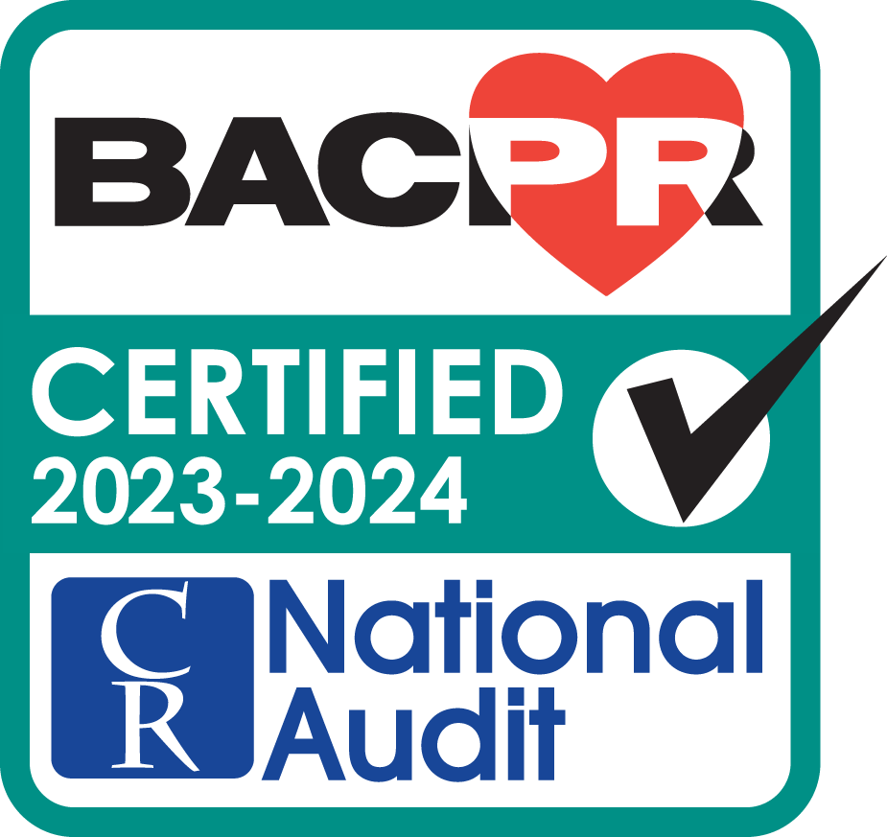

All presentations can also be found online on our Trust website and Facebook with voice-overs

|  |  |  |  |  |
| --- | --- | --- | --- | --- |
|  | **Monday 3pm-4pm**  **St Catherine’s** | **Tuesday 11am-12am**  **St Catherine’s** | **Thursday 3pm-4pm**  **St Catherine’s** | **Friday 11am-12pm**  **St Catherine’s** |
| **JUL** | 1st Stress and heart health  8th AF and stroke  15th Getting back on track  22nd Weight management  29th HF explained | 2nd Cardiac conditions  9th Basic Life Support and AED use  16th Exercise for a healthy heart  23rd Healthy eating  30th Healthy mind, healthy heart | 4th Healthy mind, healthy heart  11th CVD and the heart  18th Managing medicines  25th Risk factors | 5th Heart failure explained  12th Cardiac conditions  19th Basic Life Support and AED use  26th Exercise for a healthy heart |
| **AUG** | 5th Cardiac conditions  12th Basic Life Support and AED use  19th Exercise for a healthy heart  26th BANK HOLIDAY – NO TALK | 6th CVD and the heart  13th Managing medicines  20th Risk factors  27th Stress and your heart health | 1st Stress and your heart health  8th AF and stroke  15th Getting back on track  22nd Weight management  29th Heart failure explained | 2nd Healthy eating  9th Healthy mind, healthy heart  16th CVD and the heart  23rd Managing medicines  30th Risk factors |
| **SEPT**  **SEPT** | 2nd Healthy eating  9th Healthy mind, healthy heart  16th CVD and the heart  23rd Managing medicines  30th Risk factors | 3rd AF and stroke  10th Getting back on track  17th Weight management  24th Heart failure explained | 5th Cardiac conditions  12th Basic Life Support and AED use  19th Exercise for a healthy heart  26th Healthy eating | 6th Stress and your heart health  13th AF and stroke  20th Getting back on track  27th Weight management |
| **OCT** | 7th Stress and your heart health  14th AF and stroke  21st Getting back on track  28th Weight management | 1st Cardiac conditions  8th Basic Life Support and AED use  15th Exercise for a healthy heart  22nd Healthy eating  29th Healthy mind, healthy heart | 3rd Healthy mind, healthy heart  10th CVD and the heart  17th Managing medicines  24th Risk factors  31st Stress and your heart health | 4th Heart failure explained  11th Cardiac conditions  18th Basic Life Support and AED use  25th Exercise for a healthy heart |
| **NOV** | 4th Heart failure explained  11th Cardiac conditions  18th Basic Life Support and AED use  25th Exercise for a healthy heart | 5th CVD and the heart  12th Managing medicines  19th Risk factors  26th Stress and your heart health | 7th AF and stroke  14th Getting back on track  21st Weight management  28th Heart failure explained | 1st Healthy eating  8th Healthy mind, healthy heart  15th CVD and the heart  22nd Managing medicines  29th Risk factors |
| **DEC** | 2nd Healthy eating  9th Healthy mind, healthy heart  16th CVD and the heart  23rd Managing medicines  30th NO TALK | 3rd AF and stroke  10th Getting back on track  17th Weight management  24th Heart failure explained  31st NO TALK | 5th Cardiac conditions  12th Basic Life Support and AED use  19th Exercise for a healthy heart  26th BANK HOLIDAY – NO TALK | 6th Stress and your heart health  13th AF and stroke  20th Getting back on track  27th NO TALK |